A CASE-STUDY BASED REPORT
ON
Feature Importance Analysis for Wine Quality Using Random Forest
submitted in partial fulfilment of the requirements for the Course
MACHINE LEARNING
BACHELOR OF TECHNOLOGY
in
A.Y.: 2026-27
by
V. Siri Chandana
Roll No.: 2520030609
Under the Esteemed guidance of
Mr. Shaik Asif
Asst.Professor, Dept. of CSE




INDEX
Abstract 3
Introduction 4
Background 4
Motivation for the Project 5
Overview of the Work Carried Out 5
Scope and Responsible-Use Statement 7
Problem Statement 8
Case-Study Scenario 8
Central Case-Study Question 9
Formal Problem Definition 9
Objectives that Guide the Study 10
Assumptions and Limitations 11
Dataset and Exploratory Data Analysis 13
About the Dataset 13
Purpose of EDA 14
Preparation Steps Actually Performed 15
EDA Exploration – Implementation 17
Feature Importance Analysis 22
Summary of EDA Findings 25
Algorithm Selection and Implementation 27
Why Random Forest? 29
Why Feature Importance Analysis? 32
Permutation Feature Importance 34
Random Forest Feature Importance vs Permutation Importance 36
Algorithm Implementation Summary 36
Web Application Implementation 37
Conclusion 40
References 40

Signature of the Team Member

1. Abstract
Wine quality is an important factor in the food and beverage industry because it affects customer satisfaction and product value. Because wine quality depends on several chemical properties, understanding the relationship between these properties and quality scores can be difficult through manual analysis alone. This case study, Feature Importance Analysis for Wine Quality Using Random Forest, addresses this problem using the Red Wine Quality Dataset, which contains 1,599 wine records and 12 columns. Eleven numerical chemical properties were selected as input features: fixed acidity, volatile acidity, citric acid, residual sugar, chlorides, free sulfur dioxide, total sulfur dioxide, density, pH, sulphates and alcohol. The dataset was checked for missing values and explored using Exploratory Data Analysis (EDA) before applying the machine learning model.
The prepared data were divided into training and testing sets using an 80:20 split, resulting in 1,279 training samples and 320 testing samples. A Random Forest Classifier with 100 decision trees was used to predict wine quality. The implemented model achieved an accuracy of 67.81% on the test data. A confusion matrix and classification report were used to evaluate the prediction performance. Feature importance analysis was then performed using the Random Forest model to identify which chemical properties were most useful for the predictions. The three most important features were alcohol, sulphates and volatile acidity. The trained model was also saved and integrated with a FastAPI backend and web-based frontend, allowing users to enter chemical properties and obtain a predicted wine quality score. The project is a supervised machine learning and feature-analysis task; the identified feature importance represents the usefulness of features to the model and should not be interpreted as direct causal effects on wine quality.
Keywords: Red Wine Quality Dataset; Random Forest; wine quality prediction; feature importance; machine learning; exploratory data analysis; supervised learning; FastAPI.

2. Introduction

2.1 Background
Wine quality is an important factor in the food and beverage industry because it can affect product value, customer satisfaction, and the overall quality of the wine. Traditionally, wine quality is evaluated by experts using characteristics such as taste, smell, and appearance. However, manual evaluation can be time-consuming, costly, and may vary between different experts. Chemical analysis provides another way to describe wine through measurable properties such as acidity, sugar, pH, sulphates, and alcohol.
When a wine dataset contains several chemical properties, it becomes difficult to understand which properties are most useful for predicting the quality of wine by looking at the data table alone. Machine learning can be used to analyze these properties and identify patterns between the chemical measurements and the recorded quality scores.
This project uses Random Forest, a supervised machine learning algorithm based on multiple decision trees. Random Forest can learn relationships between the input chemical features and wine quality and can also provide feature importance, which helps identify the features that are most useful for the model's predictions. In this project, Random Forest is used both for wine quality prediction and for analyzing the importance of the chemical properties.
The project uses the Red Wine Quality Dataset, which contains 1,599 red wine records and 12 columns. Eleven chemical properties are used as input features: fixed acidity, volatile acidity, citric acid, residual sugar, chlorides, free sulfur dioxide, total sulfur dioxide, density, pH, sulphates, and alcohol. The quality column is used as the target variable.

Supporting Literature
The project is related to previous research on machine learning-based wine quality prediction and feature importance analysis. The reference study “Machine Learning on Wine Quality: Prediction and Feature Importance Analysis” by Quanyue Xie (2023) investigated machine learning methods for wine quality prediction and reported that alcohol was one of the most important features for the Random Forest model. The study also demonstrated the use of feature importance to understand the contribution of wine properties to model predictions.
This project is different in its implementation because it uses the Red Wine Quality Dataset and performs both Random Forest feature importance and permutation feature importance. The methodology presented in this project is based on the implementation carried out using the selected dataset, preprocessing, Random Forest model, evaluation methods, and feature-importance analysis.

2.2 Motivation for the Project
The Red Wine Quality Dataset contains 1,599 wine records, with 11 chemical properties for each wine. This results in a large number of individual measurements that are difficult to compare manually. Looking at each chemical property separately also does not provide a complete understanding of which properties are most useful for determining wine quality.
A machine learning approach can analyze all the chemical properties together and learn patterns from previously evaluated wine samples. This can provide a faster and more systematic method for predicting the quality score of a new wine sample.
The main motivation of this project is therefore to develop a Random Forest model that can predict wine quality from chemical properties and to determine which chemical properties are most important for the model's predictions. Understanding feature importance can make the model results easier to interpret and can provide useful information about the chemical characteristics associated with wine quality.

2.3 Overview of the Work Carried Out
The work follows the pipeline implemented in the project notebooks and application. The Red Wine Quality Dataset is loaded and inspected; the dataset is checked for missing values and basic statistical information; the 11 chemical properties are selected as input features and quality is selected as the target variable; the data are divided into training and testing sets using an 80:20 split; and a Random Forest Classifier with 100 decision trees is trained on the training data.
After training, the model is used to predict wine quality for the test data. The model performance is evaluated using accuracy, classification report, and confusion matrix. Feature importance is then calculated using the Random Forest model to identify the chemical properties that contribute most to the model's predictions. Permutation importance is also used as an additional feature-importance method.
The trained model is saved and integrated with a FastAPI backend and web-based frontend. The application allows a user to enter the chemical properties of a red wine sample and receive a predicted quality score and quality category.
The complete workflow is shown below:
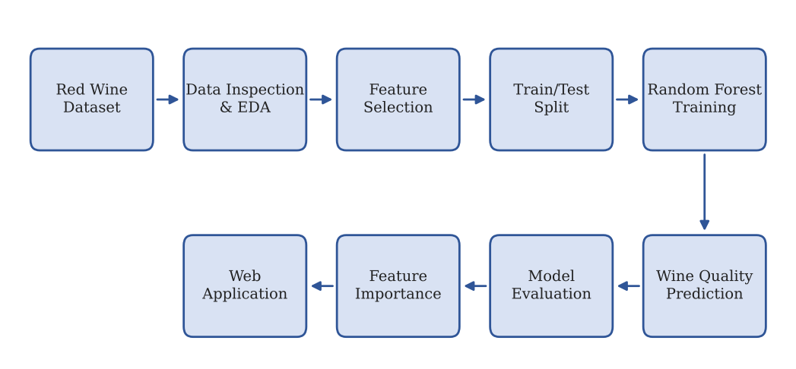
Figure 1: Complete Workflow of the Implemented Pipeline
Table 1: Stages of the Implemented Pipeline
Stage | What is done | Tool used
Data Loading | Red Wine Quality Excel dataset loaded; shape (1,599, 12) confirmed | pandas.read_excel
Data Inspection | First rows, columns, data types, missing values and statistical summary checked | Pandas
Data Cleaning | Missing values checked and handled where required | Pandas
Feature Selection | 11 chemical properties selected as input features and quality selected as target | Pandas
Train/Test Split | Data divided into 80% training and 20% testing using stratification | train_test_split
Random Forest | Random Forest Classifier with 100 decision trees trained | sklearn.ensemble.RandomForestClassifier
Prediction | Wine quality predicted for the test dataset | Random Forest
Evaluation | Accuracy, classification report and confusion matrix generated | sklearn.metrics
Feature Importance | Importance of the 11 chemical features calculated | model.feature_importances_
Permutation Importance | Features evaluated by measuring the effect of feature permutation on model performance | permutation_importance
Visualization | Quality distribution, confusion matrix and feature-importance graphs generated | Matplotlib
Web Application | Trained model connected to a web interface for new wine-quality predictions | FastAPI + HTML/CSS/JavaScript

The implemented Random Forest model achieved an accuracy of 67.81% on the test dataset. The feature-importance analysis identified alcohol, sulphates, and volatile acidity as the three most important features according to the Random Forest model.

2.4 Scope and Responsible-Use Statement
This project is a supervised machine learning and feature-importance analysis of the Red Wine Quality Dataset. It is intended to demonstrate how chemical properties can be used to predict recorded wine-quality scores and how feature importance can help interpret the model. The following boundaries apply to the whole project:
- The project is supervised machine learning because the quality column is used as the target variable for prediction.
- The project uses the Red Wine Quality Dataset, containing 1,599 red wine records and 11 chemical input features.
- The project does not replace professional wine tasting or expert quality evaluation. The predicted quality score is based only on the chemical properties provided to the machine learning model.
- The model should not be used as the only basis for commercial decisions such as accepting, rejecting, pricing, or selling wine. Human expertise and other quality-control procedures may still be required.
- The Random Forest feature-importance values indicate how useful the features are to the trained model. They should not be interpreted as proof that a feature directly causes higher or lower wine quality.
- The reported 67.81% accuracy represents the performance obtained on the test data used in this project. It should not be interpreted as a guarantee that the model will achieve the same performance on every new wine dataset.
- The dataset contains an imbalanced distribution of quality scores, with quality scores 5 and 6 occurring much more frequently than some other quality classes. Therefore, accuracy should be considered together with the classification report and confusion matrix.
- The project uses both Random Forest feature importance and permutation importance to provide a broader understanding of feature usefulness rather than relying on only one importance measure.
- The web application is intended as a project demonstration and prediction tool. It should not be considered a certified wine-quality testing system.

3. Problem Statement
Wine quality evaluation is an important task in the food and beverage industry, where the quality of a wine can depend on several chemical properties. The Red Wine Quality Dataset used in this project contains 1,599 wine records, and each wine is described using 11 numerical chemical attributes: fixed acidity, volatile acidity, citric acid, residual sugar, chlorides, free sulfur dioxide, total sulfur dioxide, density, pH, sulphates, and alcohol. The quality attribute represents the recorded quality score of each wine.
Analyzing all these chemical properties manually makes it difficult to understand their combined relationship with wine quality. Simple tables and individual comparisons do not easily reveal:
- which chemical properties are most useful for predicting wine quality;
- how different chemical properties contribute to the model's predictions;
- how accurately wine quality can be predicted from the chemical measurements; and
- which features should receive greater attention during model analysis.

Therefore, a Machine Learning-based approach is required that can use multiple chemical properties together to predict wine quality and identify the most important features. This project uses the Random Forest Classifier to learn patterns from the chemical properties and predict wine-quality scores. Random Forest feature importance and permutation importance are then used to analyze the usefulness of the input features.
Table 2: Existing Approach Compared with the Proposed Approach
Aspect | Existing Approach | Proposed Approach
Method | Manual evaluation based mainly on wine characteristics and individual analysis of chemical values | Machine learning using Random Forest
Attributes handled together | Difficult to analyze all 11 chemical properties simultaneously | All 11 selected chemical properties are given to the Random Forest model together
Quality prediction | Requires manual interpretation of wine properties | Wine quality is predicted automatically from chemical measurements
Important features | Difficult to identify systematically | Random Forest feature importance and permutation importance are used
Output | Manual quality assessment and individual values | Predicted quality score, model evaluation results, confusion matrix, and feature-importance analysis

3.1 Case-Study Scenario
A wine production company produces a large number of red wine samples and needs to evaluate their quality before selling them. Traditionally, wine quality can be evaluated by experts based on characteristics such as taste, smell, and appearance. However, manually evaluating a large number of samples can be time-consuming and costly, and the evaluation may vary between different experts.
The company has chemical measurements for previous red wine samples, including fixed acidity, volatile acidity, citric acid, residual sugar, chlorides, sulfur dioxide, density, pH, sulphates, and alcohol, along with their recorded quality scores.
The company wants to use these available chemical measurements to build a machine learning model that can predict the quality of a new wine sample. At the same time, the company wants to understand which chemical properties are most useful for the prediction.
The analyst therefore needs to answer the question: Can the quality of red wine be predicted using its chemical properties, and which chemical properties are most important for the prediction?
Case outcome. By applying Random Forest to the wine-quality dataset, the analyst can use the chemical properties together to predict wine-quality scores and evaluate the model using accuracy, classification report, and confusion matrix. Feature importance analysis can then be used to identify the most useful chemical properties. In this project, alcohol, sulphates, and volatile acidity were identified as the three most important features according to the Random Forest feature-importance results.
The case remains a machine learning analysis and project demonstration. The model should not be treated as a replacement for professional wine-quality testing or expert evaluation.

3.2 Central Case-Study Question
The case study is guided by the following central question:
How can Random Forest be used to predict red wine quality from chemical properties and identify the most important features influencing the model's predictions?

3.3 Formal Problem Definition
Let the selected dataset contain n = 1,599 wine records and d = 11 numerical input features. For each wine sample, the input vector xᵢ ∈ ℝ¹¹ contains the values of fixed acidity, volatile acidity, citric acid, residual sugar, chlorides, free sulfur dioxide, total sulfur dioxide, density, pH, sulphates, and alcohol.
The target variable yᵢ represents the recorded wine-quality score. The problem is to learn a classification function:
f : ℝ¹¹ → Y
where Y represents the possible wine-quality classes. The dataset is divided into training and testing sets using an 80:20 split, giving 1,279 training samples and 320 testing samples.
A Random Forest Classifier with 100 decision trees is trained using the training data. The trained model is then used to predict the quality classes of the test samples. Model performance is evaluated using accuracy, classification report, and confusion matrix. Feature importance is calculated to determine which input variables are most useful for the trained model.
Table 3: Formal Definition of the Machine Learning Task
Element | Definition
Input | 11 numerical chemical properties of red wine for 1,599 samples: fixed acidity, volatile acidity, citric acid, residual sugar, chlorides, free sulfur dioxide, total sulfur dioxide, density, pH, sulphates, and alcohol
Target | Recorded quality score of the wine
Process | Train a Random Forest Classifier using the training data and use it to predict the quality class of unseen test samples
Model | Random Forest Classifier with 100 decision trees
Output | Predicted wine-quality scores for the test samples
Evaluation | Accuracy, classification report, and confusion matrix
Feature Analysis | Random Forest feature importance and permutation importance
Goal | Predict wine quality and identify the chemical properties that are most useful to the model
Learning Type | Supervised learning / classification

Nature of the Learning Task
This project is a supervised machine learning classification and feature-importance analysis project. The quality column provides the target values used to train and evaluate the Random Forest model. Unlike an unsupervised dimensionality-reduction task, this project has a known target variable that the model attempts to predict.
The implemented model achieved an accuracy of 67.81% on the test dataset. Since the quality classes are not equally distributed, accuracy is considered together with the classification report and confusion matrix.

3.4 Objectives that Guide the Study
- Analyze the Red Wine Quality Dataset containing 1,599 wine records.
- Identify and use the 11 numerical chemical properties as input features.
- Perform basic Exploratory Data Analysis (EDA) to understand the dataset.
- Check and handle missing values before model training.
- Divide the dataset into training and testing sets using an 80:20 split.
- Develop a Random Forest Classifier with 100 decision trees.
- Predict the quality of red wine using its chemical properties.
- Evaluate the model using accuracy, classification report, and confusion matrix.
- Perform Random Forest feature-importance analysis to identify the most useful chemical properties.
- Perform permutation feature importance as an additional feature-analysis method.
- Compare the feature-importance results and identify the major features associated with the model's predictions.
- Integrate the trained model with a FastAPI backend and web-based frontend to demonstrate wine-quality prediction for new input values.

3.5 Assumptions and Limitations

Assumptions
- The 11 selected chemical properties are suitable input features for predicting the recorded wine-quality scores.
- The quality scores in the dataset are treated as the correct target values for supervised machine learning.
- The training and testing data are representative enough to demonstrate the Random Forest model for this project.
- Random Forest is suitable for this task because it can handle multiple numerical features and can model nonlinear relationships.
- The feature-importance values are assumed to provide useful information about which features the trained Random Forest model relies on most.
- The test dataset is kept separate from the training dataset so that model performance can be evaluated on unseen samples.

Limitations
- The Random Forest model achieved an accuracy of 67.81%, so the model does not predict every wine-quality class correctly.
- The dataset is imbalanced, with quality scores 5 and 6 occurring much more frequently than quality scores 3, 4, and 8. As a result, some minority classes are difficult for the model to predict.
- The model produced no correct predictions for some of the less frequent quality classes in the test data, so accuracy alone does not completely describe the model's performance.
- The project uses only the chemical properties available in the selected dataset. Other factors that may affect wine quality are not included.
- Feature importance represents the usefulness of a feature to the trained model, not a direct causal relationship between that chemical property and wine quality.
- The Random Forest feature-importance values and permutation-importance values can differ because they measure feature usefulness using different approaches.
- The model is trained on a specific red-wine dataset, so its performance may change when it is applied to a different wine dataset or a different population of wines.
- The web application is intended for academic demonstration and project use. It should not be considered a certified wine-quality testing system or used as the only basis for commercial wine-quality decisions.

4. Dataset and Exploratory Data Analysis

4.1 About the Dataset
The dataset used in this project is the Red Wine Quality Dataset, supplied as an Excel file named Red_Wine_Quality_Dataset.xlsx. Loading it in the notebook gives a table with 1,599 rows (wine samples) and 12 columns. The dataset contains 11 chemical properties of red wine and one target column representing wine quality.
The columns are: fixed acidity, volatile acidity, citric acid, residual sugar, chlorides, free sulfur dioxide, total sulfur dioxide, density, pH, sulphates, alcohol, and quality. The first eleven columns are used as input features, while quality is the target variable.
Eleven numerical columns were selected for Random Forest classification. They are listed in Table 4 with their data types and observed ranges in the dataset.
Table 4: The eleven selected numerical features
# | Feature | Data Type | Observed Range | Remark
1 | Fixed Acidity | float64 | 4.6 – 15.9 | Amount of fixed acids in wine
2 | Volatile Acidity | float64 | 0.12 – 1.58 | Amount of volatile acids
3 | Citric Acid | float64 | 0.00 – 1.00 | Citric acid content
4 | Residual Sugar | float64 | 0.9 – 15.5 | Sugar remaining after fermentation
5 | Chlorides | float64 | 0.012 – 0.611 | Salt/chloride content
6 | Free Sulfur Dioxide | float64 | 1 – 72 | Free sulfur dioxide content
7 | Total Sulfur Dioxide | float64 | 6 – 289 | Total sulfur dioxide content
8 | Density | float64 | 0.99007 – 1.00369 | Density of the wine
9 | pH | float64 | 2.74 – 4.01 | Acidity level measured using pH
10 | Sulphates | float64 | 0.33 – 2.00 | Sulphate content
11 | Alcohol | float64 | 8.4 – 14.9 | Alcohol percentage
12 | Quality | int64 | 3 – 8 | Target wine-quality score

All eleven input features are numerical, which makes them directly suitable for the Random Forest algorithm. The target variable, quality, contains six possible quality scores ranging from 3 to 8.
The dataset contains 1,599 wine samples. The quality values are not evenly distributed. Quality scores 5 and 6 occur most frequently, while scores 3 and 8 occur only a small number of times. Therefore, the dataset has an imbalanced target distribution.
The project uses only the Red Wine Quality Dataset. No additional dataset is used.

4.2 Purpose of EDA
Exploratory Data Analysis (EDA) is carried out before applying the machine learning algorithm in order to understand the dataset and check whether the data are suitable for Random Forest classification.
In this project, EDA is used to understand:
- the structure of the dataset, including the number of rows and columns;
- the column names and first records;
- the data types of the columns;
- missing values;
- duplicate records;
- statistical properties of the numerical features;
- the distribution of wine-quality scores;
- relationships between numerical features; and
- the suitability of the selected features for Random Forest classification.

Table 5 shows the EDA aspects examined in the current project and how they were addressed.
Table 5: EDA aspects and how they were addressed
EDA Aspect | Addressed in the Project? | How
Dataset structure | Yes | df.shape, df.head(), and column names
Data types | Yes | df.dtypes
Missing values | Yes | df.isnull().sum()
Duplicates | Yes | Duplicate checking using df.duplicated()
Statistical summary | Yes | df.describe()
Quality distribution | Yes | df["quality"].value_counts().sort_index()
Feature relationships | Yes | Correlation matrix / heatmap
Distributions | Yes | Wine quality distribution bar chart
Outlier analysis | Optional / not used for removal | No records were removed based on statistical outlier detection
Feature suitability | Yes | Numerical features, missing-value check, statistical analysis and correlation analysis

The EDA showed that all 1,599 records and 12 columns are available for the project. The selected input features are numerical and can be directly supplied to the Random Forest model.

4.3 Preparation Steps Actually Performed
The preparation steps used in the project are described in the order in which they are performed. Table 6 summarizes the main preparation steps.
Table 6: Preparation steps performed in the project
Step | Action | Result Reported by the Project
1. Dataset loading | pd.read_excel("Red_Wine_Quality_Dataset.xlsx") | Shape (1599, 12)
2. Dataset inspection | First rows, column names and data types displayed | 12 columns containing 11 input features and 1 target
3. Missing-value check | df.isnull().sum() | No missing values in the dataset
4. Statistical summary | df.describe() | Mean, standard deviation, minimum and maximum values examined
5. Quality distribution | df["quality"].value_counts().sort_index() | Quality scores 3–8 observed
6. Feature selection | X = df.drop(columns=["quality"]) | 11 input features selected
7. Target selection | y = df["quality"] | Wine quality selected as target
8. Train-test split | train_test_split(..., test_size=0.2, stratify=y) | 1,279 training and 320 testing samples
9. Model creation | RandomForestClassifier(n_estimators=100, random_state=42) | Random Forest with 100 trees
10. Model training | model.fit(X_train, y_train) | Model trained successfully
11. Prediction | model.predict(X_test) | Quality predictions generated
12. Feature importance | model.feature_importances_ | Importance of all 11 features calculated
13. Permutation importance | permutation_importance() | Additional feature-importance analysis performed

Missing Values
The notebook reports zero missing values in all 12 columns. Therefore, no missing-value imputation was required for the actual dataset used in the project.
The following check was used:
print(df.isnull().sum())

The result showed zero missing values for every column.
Therefore, all 1,599 wine samples could be used for the analysis without removing records because of missing data.

Duplicates
Duplicate records were checked during the data-preparation stage. Duplicate checking is useful because repeated records can affect model training and analysis.
No records were removed solely based on the duplicate check in the final project workflow.

Feature and Target Selection
The dataset contains eleven chemical properties and one target variable.
The input matrix is defined as:
X = df.drop(columns=["quality"])

The target variable is defined as:
y = df["quality"]

Therefore:
- X = 11 chemical input features
- y = wine quality
- Number of samples = 1,599

Train-Test Split
The dataset was divided into training and testing data using an 80:20 split.
X_train, X_test, y_train, y_test = train_test_split(
X, y,
test_size=0.2,
random_state=42,
stratify=y
)

The resulting sizes were:
- Training data: 1,279 samples × 11 features
- Testing data: 320 samples × 11 features

Stratification was used so that the distribution of wine-quality classes is maintained as much as possible in both training and testing sets.

Standardization
StandardScaler was not used in the final Random Forest implementation.
This is because Random Forest is a tree-based algorithm and does not require all input features to be on the same numerical scale. The model makes decisions using feature thresholds rather than distance calculations.
Therefore, the original numerical values were supplied directly to the Random Forest model.
The project instead focuses on Random Forest's ability to identify important features from the original chemical measurements.

4.4 EDA Exploration – Implementation
The EDA notebook is an end-to-end analysis of the Red Wine Quality Dataset. The exploration is presented below in the order in which it is performed: dataset structure, data types, missing values, statistical summary, quality distribution, and feature relationships.

Dataset Structure and Selected Data
The dataset is first loaded from the Excel file:
df = pd.read_excel("Red_Wine_Quality_Dataset.xlsx")

The first five rows are displayed using:
print(df.head())

The dataset shape is:
(1599, 12)

This indicates that the dataset contains 1,599 wine samples and 12 columns.
The selected input feature matrix contains the following eleven features:
- fixed acidity
- volatile acidity
- citric acid
- residual sugar
- chlorides
- free sulfur dioxide
- total sulfur dioxide
- density
- pH
- sulphates
- alcohol

The target variable is:
quality

Statistical Summary
The describe() function was used to examine the statistical properties of the dataset.
print(df.describe())

The important mean values observed in the dataset are shown below.
Table 7: Statistical summary of selected variables
Feature | Mean
Fixed Acidity | 8.319637
Volatile Acidity | 0.527821
Citric Acid | 0.270976
Residual Sugar | 2.538806
Chlorides | 0.087467
Free Sulfur Dioxide | 15.874922
Total Sulfur Dioxide | 46.467792
Density | 0.996747
pH | 3.311113
Sulphates | 0.658149
Alcohol | 10.422983
Quality | 5.636023

The statistical summary shows that the chemical properties have different numerical ranges and distributions. For example, alcohol has an average value of approximately 10.42, while pH has an average value of approximately 3.31.

Wine Quality Distribution
The distribution of the target variable was examined using:
df["quality"].value_counts().sort_index()

The results are shown in Table 8.
Table 8: Distribution of wine-quality scores
Quality Score | Number of Wines
3 | 10
4 | 53
5 | 681
6 | 638
7 | 199
8 | 18

The distribution shows that quality scores 5 and 6 are the most common classes. Quality scores 3 and 8 are comparatively rare.
This indicates that the target variable is imbalanced. This imbalance is important when interpreting the classification results because the model may perform better on the common quality classes than on the rare classes.
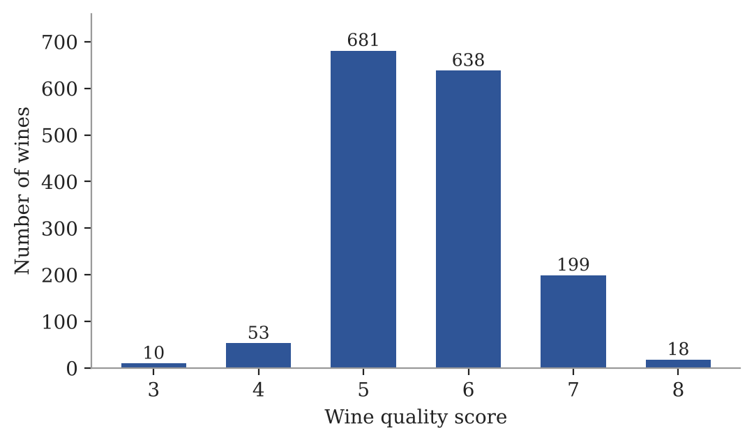
Figure 2: Distribution of Wine Quality
The project generates a bar chart showing the number of wines for each quality score from 3 to 8.
The graph clearly shows that quality 5 and quality 6 contain most of the samples, while quality 3 and quality 8 contain very few samples.

Correlation Analysis
A correlation matrix was used to examine relationships between the numerical variables.
The correlation matrix can be visualized using a heatmap.
The correlation coefficient ranges from -1 to +1:
- +1 indicates a strong positive relationship.
- -1 indicates a strong negative relationship.

0 indicates little or no linear relationship.
The heatmap helps identify relationships between chemical properties such as acidity, sulphates, density and alcohol.
The correlation analysis is used only to understand relationships in the dataset. Correlation should not be interpreted as causation, and correlation values should not be confused with Random Forest feature importance.
[Insert the correlation heatmap of the Red Wine features here — generated from the dataset in your notebook (sns.heatmap(df.corr()))]
Figure 3: Correlation Heatmap of Red Wine Features
The correlation heatmap provides a visual representation of the relationships between the numerical attributes of the wine dataset.

Random Forest Model Preparation
After completing the EDA, the data are divided into input features and the target variable.
X = df.drop(columns=["quality"])
y = df["quality"]

The data are then divided into training and testing sets:
- Training samples = 1,279
- Testing samples = 320
- Input features = 11
- Target = quality

A Random Forest Classifier containing 100 decision trees is then created:
model = RandomForestClassifier(
n_estimators=100,
random_state=42
)

The model is trained using:
model.fit(X_train, y_train)

After training, the model predicts the quality of the test samples.
y_pred = model.predict(X_test)

Model Performance
The trained Random Forest model achieved an accuracy of:
67.8125%
or approximately:
67.81%
The classification report was also generated to evaluate the performance for each wine-quality class.
Table 9: Random Forest classification results
Quality | Precision | Recall | F1-Score | Support
3 | 0.00 | 0.00 | 0.00 | 2
4 | 0.00 | 0.00 | 0.00 | 11
5 | 0.71 | 0.76 | 0.73 | 136
6 | 0.65 | 0.70 | 0.67 | 128
7 | 0.71 | 0.55 | 0.62 | 40
8 | 0.50 | 0.33 | 0.40 | 3
Overall Accuracy |  |  | 0.68 | 320

The model performs better for the common classes, especially quality 5 and 6. The rare classes 3 and 4 were not predicted correctly in the test set. This is mainly associated with the imbalanced distribution of the target variable.

Confusion Matrix
A confusion matrix was generated to compare actual wine-quality values with predicted values.
The resulting matrix was:
[[ 0 1 1 0 0 0]
[ 0 0 9 2 0 0]
[ 0 0 104 31 1 0]
[ 0 0 31 90 7 0]
[ 0 0 2 15 22 1]
[ 0 0 0 1 1 1]]

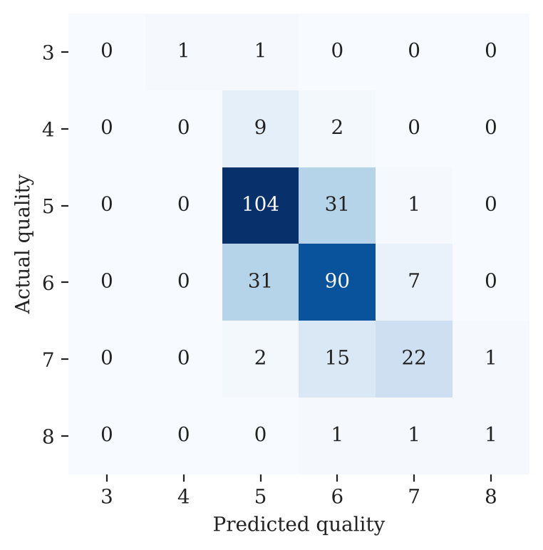
Figure 4: Confusion Matrix of Random Forest Predictions
The confusion matrix shows that the model correctly predicts many of the quality 5 and 6 samples, while the minority quality classes have fewer correct predictions.

4.5 Feature Importance Analysis
A major objective of this project is to identify which chemical properties are most useful for predicting wine quality.
Random Forest provides a built-in feature-importance measure through:
model.feature_importances_

The feature importance values obtained from the trained Random Forest model are shown in Table 10.
Table 10: Random Forest feature importance
Rank | Feature | Importance
1 | Alcohol | 0.152106
2 | Sulphates | 0.112057
3 | Volatile Acidity | 0.103678
4 | Total Sulfur Dioxide | 0.101487
5 | Density | 0.088812
6 | Chlorides | 0.079941
7 | pH | 0.079460
8 | Fixed Acidity | 0.076209
9 | Residual Sugar | 0.073386
10 | Citric Acid | 0.068562
11 | Free Sulfur Dioxide | 0.064303

The results show that alcohol has the highest Random Forest feature importance, followed by sulphates and volatile acidity.
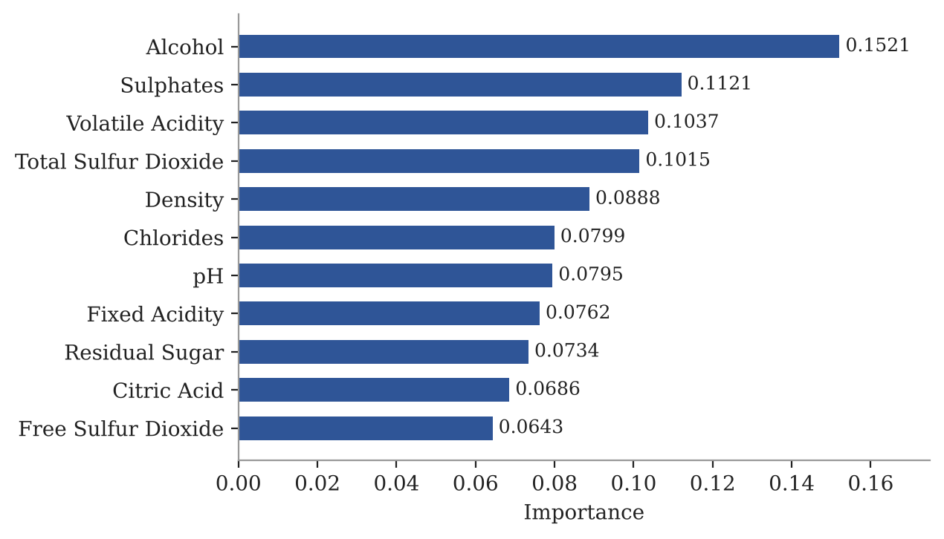
Figure 5: Feature Importance Using Random Forest
The feature-importance graph ranks the eleven chemical properties according to their contribution to the Random Forest model.
The three highest-ranked features are:
- Alcohol
- Sulphates
- Volatile Acidity

These results indicate that these three features were particularly useful to the trained Random Forest model when making its predictions.
However, feature importance indicates model usefulness, not a direct causal relationship with wine quality.

Permutation Feature Importance
In addition to the built-in Random Forest importance, permutation importance was also performed.
Permutation importance measures how much the model's performance changes when the values of one feature are randomly shuffled.
The results are shown in Table 11.
Table 11: Permutation feature importance
Rank | Feature | Permutation Importance
1 | Alcohol | 0.130625
2 | Sulphates | 0.065937
3 | Volatile Acidity | 0.048125
4 | Total Sulfur Dioxide | 0.021562
5 | Free Sulfur Dioxide | 0.011875
6 | Chlorides | 0.010312
7 | Citric Acid | 0.009687
8 | pH | 0.008750
9 | Density | 0.008437
10 | Residual Sugar | 0.006250
11 | Fixed Acidity | 0.001250

The permutation-importance analysis also identifies alcohol, sulphates and volatile acidity as the three most important features.
Therefore, both feature-importance methods provide a similar top-three ranking:
Alcohol → Sulphates → Volatile Acidity
This agreement provides additional support for the interpretation that these features were particularly useful to the trained model.
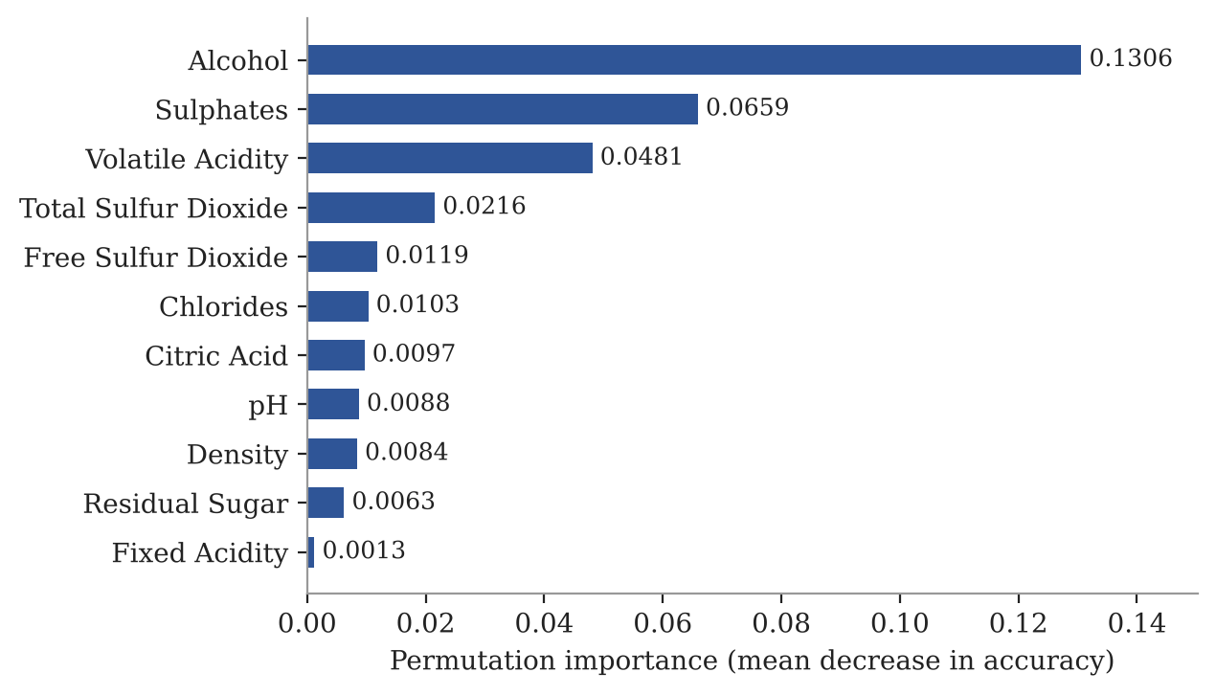
Figure 6: Permutation Feature Importance
The graph shows the effect of randomly shuffling each feature on the model's performance. Features with larger values have a greater effect on the model's predictive performance.

4.6 Summary of EDA Findings
The findings obtained from the EDA and machine learning implementation are summarized below.
- The Red Wine Quality Dataset contains 1,599 rows and 12 columns.
- The dataset contains 11 numerical chemical features and one target variable, quality.
- The selected chemical features are fixed acidity, volatile acidity, citric acid, residual sugar, chlorides, free sulfur dioxide, total sulfur dioxide, density, pH, sulphates and alcohol.
- The dataset contains no missing values, so no actual missing-value imputation was required.
- The wine-quality scores range from 3 to 8.
- Quality scores 5 and 6 are the most common classes, while quality scores 3 and 8 are rare.
- The target distribution is therefore imbalanced, which affects the classification performance for minority classes.
- Statistical analysis was performed using df.describe() to understand the numerical properties of the dataset.
- A correlation heatmap was used to examine relationships between the numerical features.
- The dataset was divided into 80% training data and 20% testing data, resulting in 1,279 training samples and 320 testing samples.
- A Random Forest Classifier with 100 decision trees was used for wine-quality prediction.
- The Random Forest model achieved an accuracy of 67.81% on the test dataset.
- The model performed better on the commonly occurring quality classes, particularly quality 5 and quality 6.
- The minority classes, especially quality 3 and 4, were difficult for the model to predict because they contain very few samples.
- StandardScaler was not required because Random Forest is a tree-based algorithm and does not require feature scaling.
- Random Forest feature importance identified alcohol as the most important feature, followed by sulphates and volatile acidity.
- Permutation importance produced the same top three features: alcohol, sulphates and volatile acidity.
- The agreement between the two feature-importance methods strengthens the interpretation of the top-ranked features.
- Feature importance represents the usefulness of a feature to the trained model and should not be interpreted as proof that a feature directly causes a particular wine-quality score.
- The EDA and model results provide the foundation for the next stage of the project, where the trained Random Forest model is used for wine-quality prediction and feature-importance analysis.

5. Algorithm Selection and Implementation
This section describes the selected algorithm and its implementation, following the notebook used for the Feature Importance Analysis for Wine Quality Using Random Forest project. The project is a supervised machine-learning classification task, where the chemical properties of red wine are used as input features to predict the wine-quality score. Random Forest is also used to identify which chemical properties are most important for the model's predictions.

Algorithm followed
- Load the Red Wine Quality Dataset from the Excel file.
- Inspect the dataset structure, columns, data types and missing values.
- Select the eleven chemical properties as input features and quality as the target.
- Perform basic Exploratory Data Analysis and examine the distribution of wine-quality scores.
- Divide the dataset into training and testing data using an 80:20 stratified split.
- Create a Random Forest Classifier with 100 decision trees.
- Train the Random Forest model using the training data.
- Predict wine-quality scores for the testing data.
- Evaluate the model using accuracy, classification report and confusion matrix.
- Calculate Random Forest built-in feature importance.
- Apply permutation feature importance as a second feature-analysis method.
- Compare the feature-importance results and identify the most important chemical properties.
- Save the trained model and feature-importance results for later use in the web application.

Implementation environment
Table 12: Software and libraries used
Item | Details
Programming language | Python 3
Environment | Jupyter-style notebook; the project was implemented using Google Colab
Libraries | pandas, NumPy, Matplotlib, Seaborn, scikit-learn
Machine learning algorithm | Random Forest Classifier
Evaluation methods | Accuracy, Classification Report, Confusion Matrix
Feature analysis | Random Forest Feature Importance and Permutation Importance
Dataset | Red_Wine_Quality_Dataset.xlsx, 1,599 rows × 12 columns
Model saving | Joblib
Web integration | FastAPI backend and HTML/CSS/JavaScript frontend

Common preparation code
The Random Forest model uses the eleven chemical properties as input features and quality as the target.
The main preparation code used in the project is:
df = pd.read_excel("Red_Wine_Quality_Dataset.xlsx")
# Shape: (1599, 12)

X = df.drop(columns=["quality"])
# Shape: (1599, 11)

y = df["quality"]
# Target variable: quality

print(X.isnull().sum())
# 0 missing values for every selected feature

The dataset is then divided into training and testing sets:
X_train, X_test, y_train, y_test = train_test_split(
X,
y,
test_size=0.2,
random_state=42,
stratify=y
)

The resulting data sizes are:
Training data: (1279, 11)
Testing data: (320, 11)

Unlike algorithms such as KNN, SVM or Logistic Regression, Random Forest does not require StandardScaler, because it is a tree-based algorithm and does not depend on distance calculations or feature magnitudes in the same way as those algorithms.

5.1 Why Random Forest?
Random Forest is an ensemble machine-learning algorithm that combines multiple decision trees to make a prediction. Instead of depending on one decision tree, Random Forest creates many trees and combines their results to produce the final prediction.
Random Forest is selected for this project because the dataset contains several numerical chemical properties that may have nonlinear relationships with wine quality. The algorithm can handle multiple numerical input features and can capture complex relationships between these features and the target quality score.
Another important reason for selecting Random Forest is that it provides a built-in feature importance measure. Since the main objective of this project is not only to predict wine quality but also to determine which chemical properties are most useful for the prediction, Random Forest is suitable for both objectives.
The algorithm therefore performs two important tasks:
- Wine quality prediction
- Feature importance analysis

Random Forest is also relatively easy to implement and interpret compared with many more complex machine-learning models.

Random Forest implementation
The Random Forest model used in the project is created using:
model = RandomForestClassifier(
n_estimators=100,
random_state=42
)

The model is trained using:
model.fit(X_train, y_train)

After training, predictions are generated using:
y_pred = model.predict(X_test)

The model performance is then evaluated using accuracy, classification report and confusion matrix.
Table 13: Explanation of the Random Forest code
Code | Explanation
RandomForestClassifier(n_estimators=100) | Creates a Random Forest model containing 100 decision trees.
random_state=42 | Sets a fixed random seed so that the experiment can be reproduced.
model.fit(X_train, y_train) | Trains the Random Forest using the training features and their corresponding quality labels.
model.predict(X_test) | Predicts the quality scores of the test samples.
accuracy_score(y_test, y_pred) | Calculates the proportion of test samples predicted correctly.
classification_report(y_test, y_pred) | Provides precision, recall, F1-score and support for each quality class.
confusion_matrix(y_test, y_pred) | Shows the relationship between actual and predicted quality classes.
model.feature_importances_ | Returns the built-in importance value assigned to each input feature.

Random Forest output
The notebook reports that the Random Forest model was successfully trained and used to predict the wine-quality scores.
The model achieved the following test accuracy:
Table 14: Random Forest model performance
Measure | Result
Training samples | 1,279
Testing samples | 320
Number of trees | 100
Number of input features | 11
Target variable | Quality
Accuracy | 67.8125%
Approximate accuracy | 67.81%

The Random Forest model therefore correctly predicted approximately 67.81% of the wine-quality values in the test dataset.
The classification report provides more detailed information about individual quality classes.
Table 15: Classification report
Quality | Precision | Recall | F1-Score | Support
3 | 0.00 | 0.00 | 0.00 | 2
4 | 0.00 | 0.00 | 0.00 | 11
5 | 0.71 | 0.76 | 0.73 | 136
6 | 0.65 | 0.70 | 0.67 | 128
7 | 0.71 | 0.55 | 0.62 | 40
8 | 0.50 | 0.33 | 0.40 | 3

The results show that the model performs better on the more common quality classes, particularly quality 5 and quality 6.
The model has difficulty predicting quality 3 and quality 4 because these classes have very few samples in the dataset.

Confusion Matrix
A confusion matrix is used to compare the actual quality values with the quality values predicted by the Random Forest model.
The resulting confusion matrix is:
[[ 0 1 1 0 0 0]
[ 0 0 9 2 0 0]
[ 0 0 104 31 1 0]
[ 0 0 31 90 7 0]
[ 0 0 2 15 22 1]
[ 0 0 0 1 1 1]]

Figure 7: Random Forest Confusion Matrix for Wine Quality Prediction
The confusion matrix shows that many quality 5 and quality 6 wines are classified correctly. However, some samples are classified into neighboring quality classes.
For example, some actual quality 5 wines are predicted as quality 6, and some actual quality 6 wines are predicted as quality 5. This indicates that distinguishing between neighboring wine-quality scores can be difficult using only the available chemical properties.

5.2 Why Feature Importance Analysis?
Feature importance analysis is an important part of this project because the objective is not limited to predicting wine quality. The project also aims to understand which chemical properties are most useful to the Random Forest model.
Random Forest provides a built-in feature-importance score for every input feature. A higher importance value means that the feature was more useful to the trained Random Forest model when making its decisions.
The feature importance is calculated using:
importance = model.feature_importances_

The feature names and their importance values are then combined into a DataFrame:
feature_importance = pd.DataFrame({
"Feature": X.columns,
"Importance": importance
})

The features are sorted from highest to lowest importance:
feature_importance = feature_importance.sort_values(
by="Importance",
ascending=False
)

Random Forest Feature Importance output
The feature importance values produced by the trained Random Forest model are shown in Table 16.
Table 16: Random Forest feature importance
Rank | Feature | Importance
1 | Alcohol | 0.152106
2 | Sulphates | 0.112057
3 | Volatile Acidity | 0.103678
4 | Total Sulfur Dioxide | 0.101487
5 | Density | 0.088812
6 | Chlorides | 0.079941
7 | pH | 0.079460
8 | Fixed Acidity | 0.076209
9 | Residual Sugar | 0.073386
10 | Citric Acid | 0.068562
11 | Free Sulfur Dioxide | 0.064303

The results show that alcohol has the highest feature importance, with an importance value of approximately 0.1521.
The next two important features are:
- Sulphates – 0.1121
- Volatile Acidity – 0.1037

Therefore, the top three features identified by the Random Forest model are:
Alcohol → Sulphates → Volatile Acidity
Figure 8: Feature Importance Using Random Forest
The feature-importance graph displays the eleven chemical properties in descending order of their importance to the Random Forest model.
The results indicate that alcohol, sulphates and volatile acidity were particularly useful to the model when predicting wine quality.
It is important to note that feature importance indicates how useful a feature is to the model, and it does not prove that the feature directly causes wine quality to increase or decrease.

5.3 Permutation Feature Importance
A second feature-analysis method, Permutation Importance, was also implemented.
Permutation importance works by randomly changing the values of one feature and observing how much the model's performance changes. If shuffling a feature causes a large decrease in model performance, that feature is considered important to the model.
The implementation used in the project is:
result = permutation_importance(
model,
X_test,
y_test,
n_repeats=10,
random_state=42
)

The results are stored in a DataFrame:
permutation_importance_df = pd.DataFrame({
"Feature": X.columns,
"Importance": result.importances_mean
})

The results are then sorted:
permutation_importance_df = permutation_importance_df.sort_values(
by="Importance",
ascending=False
)

Table 17: Permutation feature importance
Rank | Feature | Permutation Importance
1 | Alcohol | 0.130625
2 | Sulphates | 0.065937
3 | Volatile Acidity | 0.048125
4 | Total Sulfur Dioxide | 0.021562
5 | Free Sulfur Dioxide | 0.011875
6 | Chlorides | 0.010312
7 | Citric Acid | 0.009687
8 | pH | 0.008750
9 | Density | 0.008437
10 | Residual Sugar | 0.006250
11 | Fixed Acidity | 0.001250

The permutation-importance analysis again identifies alcohol, sulphates and volatile acidity as the three most important features.
Figure 9: Permutation Feature Importance
The permutation-importance graph shows how much the model's performance is affected when each chemical feature is randomly shuffled.
A higher permutation-importance value indicates that the model depends more strongly on that feature for its predictions.

5.4 Random Forest Feature Importance vs Permutation Importance
The two feature-importance methods provide complementary information.
Table 18: Comparison of feature-importance methods
Aspect | Random Forest Feature Importance | Permutation Importance
Type | Built-in model-based importance | Model-independent evaluation method
Main idea | Measures feature usefulness within the Random Forest trees | Measures change in model performance after feature shuffling
Applied to | Trained Random Forest model | Trained Random Forest model and test data
Main output | Importance score for each feature | Mean change in model performance
Top feature | Alcohol | Alcohol
Second feature | Sulphates | Sulphates
Third feature | Volatile Acidity | Volatile Acidity
Advantage | Simple and directly available from Random Forest | Provides an additional validation of feature usefulness
Limitation | Can be affected by feature characteristics and interactions | Results depend on the test data and repeated shuffling

Both methods produce the same top-three features:
- Alcohol
- Sulphates
- Volatile Acidity

This agreement is useful because the two methods approach feature importance differently.
The Random Forest method examines feature contribution within the trained trees, while permutation importance examines how model performance changes when a feature is disturbed.
Therefore, the project does not depend on only one feature-importance measure.

5.5 Algorithm Implementation Summary
The complete implementation can be summarized as follows:
Red Wine Quality Dataset
↓
Dataset Inspection
↓
EDA
↓
Select 11 Chemical Features
↓
Select Quality as Target
↓
80:20 Stratified Train-Test Split
↓
Random Forest Classifier
↓
100 Decision Trees
↓
Model Training
↓
Wine Quality Prediction
↓
Accuracy + Classification Report
↓
Confusion Matrix
↓
Random Forest Feature Importance
↓
Permutation Feature Importance
↓
Compare Feature Importance Results
↓
Identify Important Features

The final machine-learning workflow is therefore a supervised classification and feature-analysis pipeline.

5.6 Web Application Implementation
After the Random Forest model was trained, the trained model was saved using Joblib so that it could be used outside the notebook.
The saved model is:
wine_quality_model.pkl

The model was then integrated into a FastAPI backend.
The web application contains:
C:\ML_Project
│
├── backend
│ └── app.py
│
├── frontend
│ ├── index.html
│ ├── script.js
│ └── style.css
│
└── model
└── wine_quality_model.pkl

The frontend allows a user to enter the eleven chemical properties of a wine.
The values are sent to the FastAPI backend using a POST request.
The backend loads the trained Random Forest model and generates the wine-quality prediction.
The workflow is:
User enters wine properties
↓
HTML/CSS/JavaScript Frontend
↓
FastAPI Backend
↓
Saved Random Forest Model
↓
Prediction
↓
Wine Quality Score
↓
Quality Category displayed to User

For example, a sample wine with the following values:
- Fixed acidity = 7.4
- Volatile acidity = 0.70
- Citric acid = 0.00
- Residual sugar = 1.9
- Chlorides = 0.076
- Free sulfur dioxide = 11
- Total sulfur dioxide = 34
- Density = 0.9978
- pH = 3.51
- Sulphates = 0.56
- Alcohol = 9.4

was passed through the web application and the model predicted:
Predicted Quality: 5
Category: Average / Good Quality
This demonstrates that the trained Random Forest model can be used through a simple web interface rather than only through the notebook.

6. Conclusion
This case study applied supervised machine learning and feature importance analysis to the Red Wine Quality Dataset in order to predict wine quality and identify the chemical properties that are most useful to the model. The dataset contains 1,599 wine samples and 12 columns, consisting of eleven chemical properties and one quality target. The data were inspected through Exploratory Data Analysis, including dataset structure, missing-value checking, statistical analysis, quality distribution and correlation analysis.
The eleven chemical features were used as inputs to a Random Forest Classifier containing 100 decision trees. The dataset was divided using an 80:20 stratified train-test split, resulting in 1,279 training samples and 320 testing samples. The trained model achieved an accuracy of 67.81% on the test dataset. The classification report and confusion matrix showed that the model performed better on the common quality classes, particularly quality 5 and 6, while the rare quality classes were more difficult to predict.
The main objective of the project was also achieved through feature importance analysis. Random Forest feature importance identified alcohol, sulphates and volatile acidity as the top three features. Permutation importance produced the same top-three ranking, providing additional support for the feature analysis. These results show which chemical properties were particularly useful to the trained model, although feature importance should not be interpreted as direct causal influence on wine quality.
The trained model was additionally integrated into a FastAPI-based web application with an HTML, CSS and JavaScript frontend. This allows users to enter wine chemical properties and receive a predicted quality score. The project therefore demonstrates a complete machine-learning workflow from dataset analysis → EDA → model training → prediction → evaluation → feature importance → web application.
The project is intended as an academic machine-learning demonstration. The prediction accuracy is not sufficient to replace professional wine evaluation, and the model may be affected by the imbalance of wine-quality classes and by the limited set of chemical features available in the dataset.
Possible future extensions include handling class imbalance using suitable techniques, testing additional machine-learning algorithms, tuning Random Forest hyperparameters, using advanced explainability methods such as SHAP, and evaluating the model on additional wine datasets.

References
[1] Cortez, P., Cerdeira, A., Almeida, F., Matos, T., & Reis, J. Modeling wine preferences by data mining from physicochemical properties. Decision Support Systems, 47(4), 547–553, 2009.
[2] Pedregosa, F., et al. Scikit-learn: Machine Learning in Python. Journal of Machine Learning Research, 12, 2825–2830, 2011.
[3] Breiman, L. Random Forests. Machine Learning, 45, 5–32, 2001.
[4] Kaggle. Red Wine Quality Dataset, based on the Wine Quality dataset by Cortez et al.
[5] Xie, Q. Machine Learning on Wine Quality: Prediction and Feature Importance Analysis. Highlights in Science, Engineering and Technology, 41, 170–174, 2023.
[6] Pedregosa, F., et al. Scikit-learn: Machine Learning in Python. Journal of Machine Learning Research, 12, 2825–2830, 2011.
Signature of the Team Member
Signature: ____V. Siri Chandana_____

